**Question 1**

1. Implement KNN classification in iris data set  
2. Choose different values of k (from 1-25)

3. Provide the confusion Matrix for same.  
4. Then implement logistics regression for Iris data  
5. Finally compare kNN and Logistic Regression

**Source Code**

*import numpy as np*

*import matplotlib.pyplot as plt*

*from sklearn.model_selection import train_test_split*

*from sklearn.neighbors import KNeighborsClassifier*

*from sklearn.linear_model import LogisticRegression*

*from sklearn.datasets import load_iris*

*from sklearn.metrics import confusion_matrix, accuracy_score*

*iris = load_iris()*

*X = iris.data*

*y = iris.target*

*X_train, X_test, y_train, y_test = train_test_split(X, y, test_size=0.3, random_state=42)*

*# KNN Classifier with k=3*

*knn_3 = KNeighborsClassifier(n_neighbors=3)*

*knn_3.fit(X_train, y_train)*

*y_pred_knn_3 = knn_3.predict(X_test)*

*conf_matrix_knn_3 = confusion_matrix(y_test, y_pred_knn_3)*

*accuracy_knn_3 = accuracy_score(y_test, y_pred_knn_3)*

*# KNN Classifier with k=13*

*knn_13 = KNeighborsClassifier(n_neighbors=13)*

*knn_13.fit(X_train, y_train)*

*y_pred_knn_13 = knn_13.predict(X_test)*

*conf_matrix_knn_13 = confusion_matrix(y_test, y_pred_knn_13)*

*accuracy_knn_13 = accuracy_score(y_test, y_pred_knn_13)*

*# KNN Classifier with k=20*

*knn_20 = KNeighborsClassifier(n_neighbors=20)*

*knn_20.fit(X_train, y_train)*

*y_pred_knn_20 = knn_20.predict(X_test)*

*conf_matrix_knn_20 = confusion_matrix(y_test, y_pred_knn_20)*

*accuracy_knn_20 = accuracy_score(y_test, y_pred_knn_20)*

*# Logistic Regressor*

*log_reg = LogisticRegression(max_iter=200)*

*log_reg.fit(X_train, y_train)*

*y_pred_log_reg = log_reg.predict(X_test)*

*conf_matrix_log_reg = confusion_matrix(y_test, y_pred_log_reg)*

*accuracy_log_reg = accuracy_score(y_test, y_pred_log_reg)*

*print(f'Accuracy of KNN (k=3): {accuracy_knn_3 * 100:.2f}%')*

*print(f'Accuracy of KNN (k=13): {accuracy_knn_13 * 100:.2f}%')*

*print(f'Accuracy of KNN (k=20): {accuracy_knn_20 * 100:.2f}%')*

*print(f'Accuracy of Logistic Regression: {accuracy_log_reg * 100:.2f}%')*

*fig, axes = plt.subplots(2, 2, figsize=(8, 8))*

*# Plot for KNN (k=3)*

*axes[0][0].imshow(conf_matrix_knn_3, interpolation='nearest', cmap=plt.cm.Blues)*

*axes[0][0].set_title('Confusion Matrix (KNN k=3)')*

*axes[0][0].set_xticks(np.arange(3))*

*axes[0][0].set_yticks(np.arange(3))*

*axes[0][0].set_xticklabels(iris.target_names)*

*axes[0][0].set_yticklabels(iris.target_names)*

*axes[0][0].set_xlabel('Predicted Label')*

*axes[0][0].set_ylabel('True Label')*

*for i in range(3):*

*for j in range(3):*

*axes[0][0].text(j, i, conf_matrix_knn_3[i, j], ha="center", va="center", color="white")*

*# Plot for KNN (k=13)*

*axes[0][1].imshow(conf_matrix_knn_13, interpolation='nearest', cmap=plt.cm.Blues)*

*axes[0][1].set_title('Confusion Matrix (KNN k=13)')*

*axes[0][1].set_xticks(np.arange(3))*

*axes[0][1].set_yticks(np.arange(3))*

*axes[0][1].set_xticklabels(iris.target_names)*

*axes[0][1].set_yticklabels(iris.target_names)*

*axes[0][1].set_xlabel('Predicted Label')*

*axes[0][1].set_ylabel('True Label')*

*for i in range(3):*

*for j in range(3):*

*axes[0][1].text(j, i, conf_matrix_knn_13[i, j], ha="center", va="center", color="white")*

*# Plot for KNN (k=20)*

*axes[1][0].imshow(conf_matrix_knn_20, interpolation='nearest', cmap=plt.cm.Blues)*

*axes[1][0].set_title('Confusion Matrix (KNN k=20)')*

*axes[1][0].set_xticks(np.arange(3))*

*axes[1][0].set_yticks(np.arange(3))*

*axes[1][0].set_xticklabels(iris.target_names)*

*axes[1][0].set_yticklabels(iris.target_names)*

*axes[1][0].set_xlabel('Predicted Label')*

*axes[1][0].set_ylabel('True Label')*

*for i in range(3):*

*for j in range(3):*

*axes[1][0].text(j, i, conf_matrix_knn_20[i, j], ha="center", va="center", color="white")*

*# Plot for Logistic Regression*

*axes[1][1].imshow(conf_matrix_log_reg, interpolation='nearest', cmap=plt.cm.Blues)*

*axes[1][1].set_title('Confusion Matrix (Logistic Regression)')*

*axes[1][1].set_xticks(np.arange(3))*

*axes[1][1].set_yticks(np.arange(3))*

*axes[1][1].set_xticklabels(iris.target_names)*

*axes[1][1].set_yticklabels(iris.target_names)*

*axes[1][1].set_xlabel('Predicted Label')*

*axes[1][1].set_ylabel('True Label')*

*for i in range(3):*

*for j in range(3):*

*axes[1][1].text(j, i, conf_matrix_log_reg[i, j], ha="center", va="center", color="white")*

*plt.tight_layout()*

*plt.show()*

*accuracies = {*

*"KNN (k=3)": accuracy_knn_3,*

*"KNN (k=13)": accuracy_knn_13,*

*"KNN (k=20)": accuracy_knn_20,*

*"Logistic Regression": accuracy_log_reg*

*}*

*best_model = max(accuracies, key=accuracies.get)*

*print(f"\nThe best performing model is: {best_model}.")*

**Output**

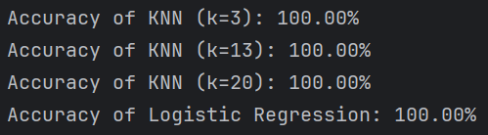*Terminal*

*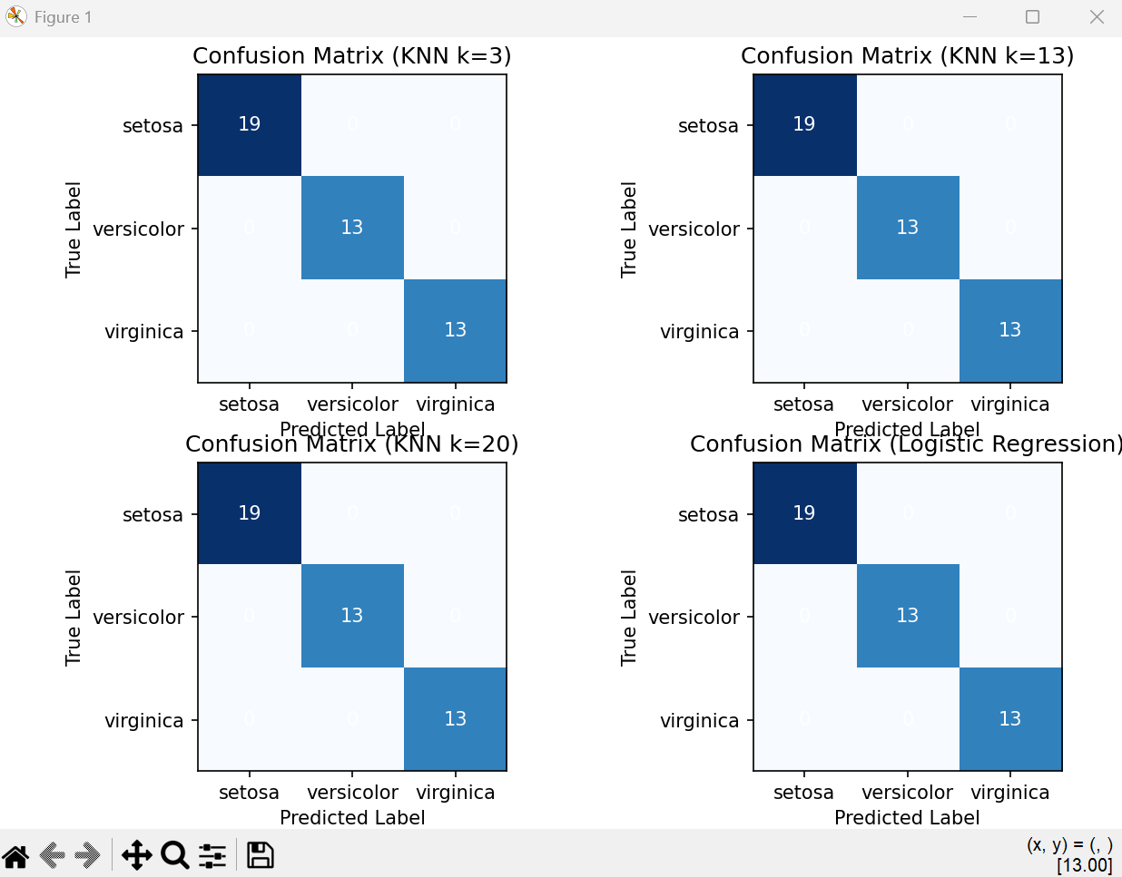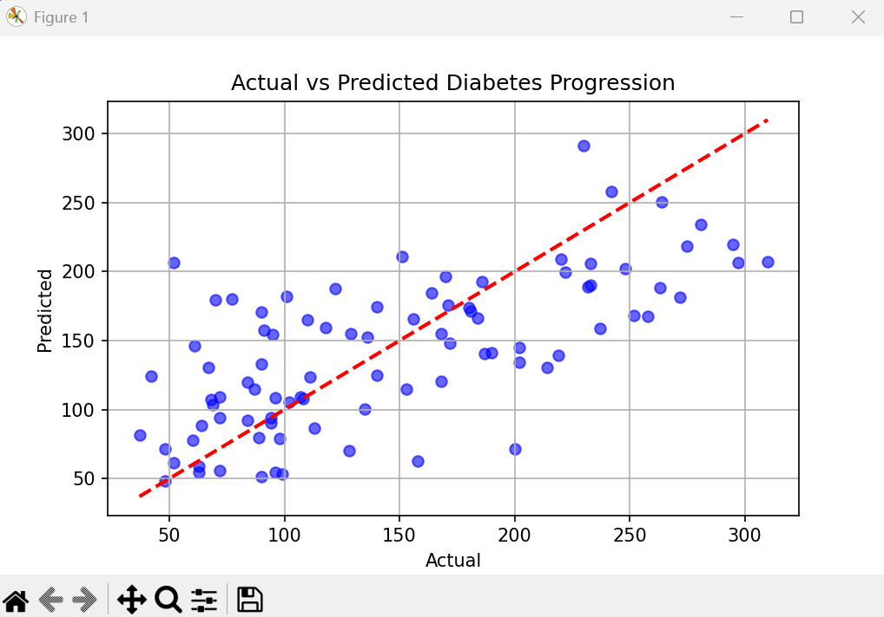Visualization*